To add a row above an existing row:
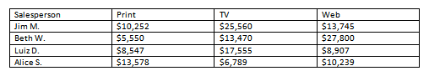
- Place the insertion point (or cursor) in a row below the location where you want to add a row.
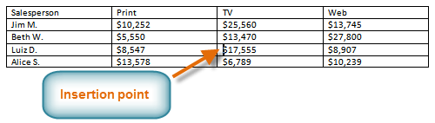
- Right-click the mouse. A menu appears.
- Select Insert

Insert Rows Above.

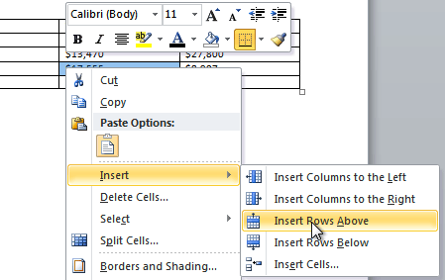

- A new row appears above the insertion point.
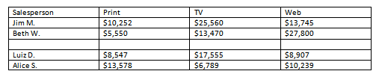
You can also add rows below the insertion point. Follow the same steps but select Insert Rows Below from the menu.

To add a column:
- Place the insertion point in a column adjacent to the location where you want the new column to appear.
- Right-click the mouse. A menu will appear.
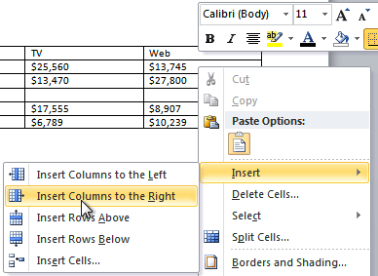
- Select InsertInsert Columns to the Left or Insert Columns to the Right. A new column appears.
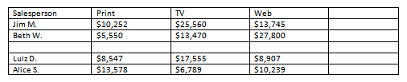

To delete a row or column:
- Select the row or column.
- Right-click your mouse. A menu will appear.
- Select Delete Cells.
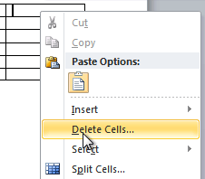
- Select Delete entire row or Delete entire column, then click OK.
