Can you name the icons and give a brief description of what you would use them for?
 | ICON | Name of Icon | Description of Icon
1 | 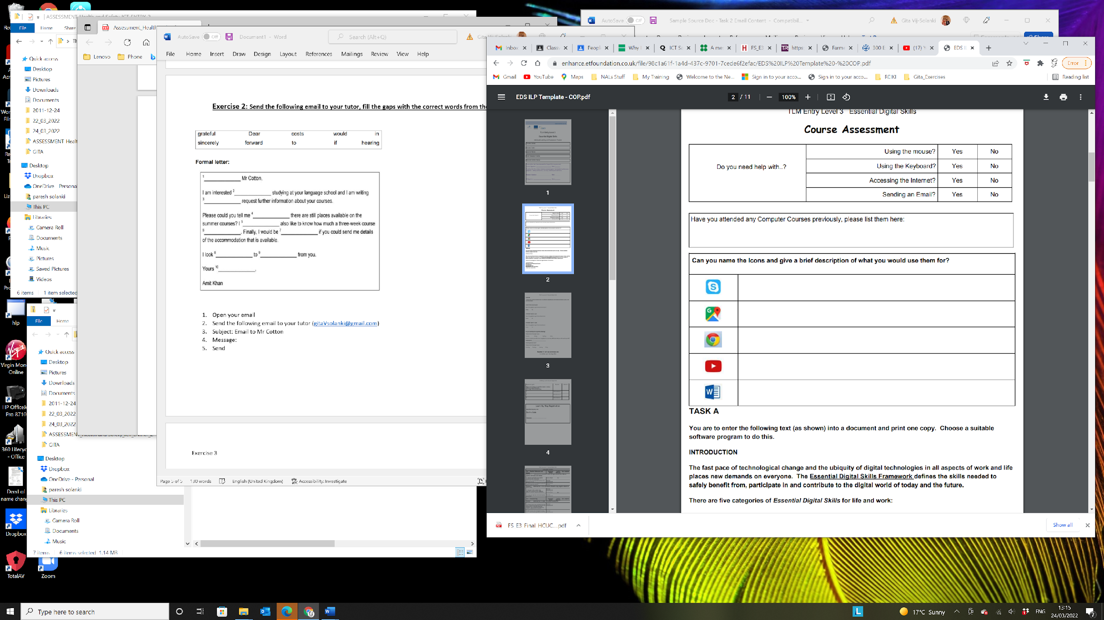
2
3
4
5
6 | 
7 | 
8 | 
9 | 
10 | 

