Use the information on the card to buy tickets.

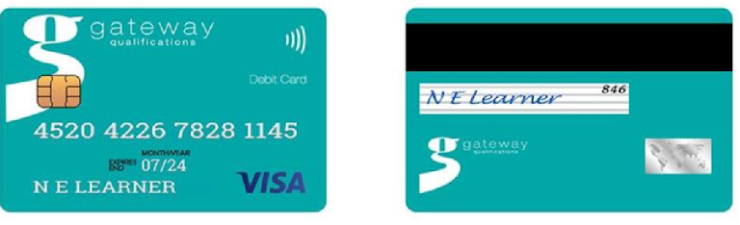

Card Number
Name
Expiry Date
Security Code

